http://apmonitor.com/pdc/index.php/Main/TankBlending
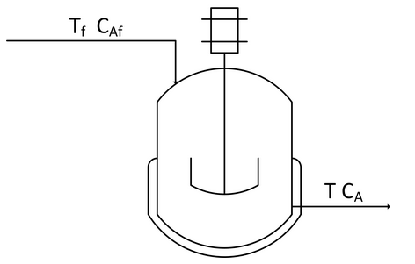
Create a dynamic model of concentration and temperature based on a physics-based derivation from species and energy balance equations. A mixing tank has a liquid inlet stream and outlet stream. The tank is well mixed so the concentration and temperature are assumed to be the same throughout the reactor.
Start with the species and energy balance equations and derive the dynamic concentration and temperature response. Develop the concentration response and then add the temperature response. Assume a constant volume V of 100 m³ and an inlet flow rate $\dot{V}$ or q of 100 m³/hr.

Species balance

$$\frac{dn_{A}}{dt}={\dot{n}}_{A_{in}}-{\dot{n}}_{A_{out}}+{\dot{n}}_{A_{gen}}-{\dot{n}}_{A_{cons}} \\ \frac{dC_{A}V}{dt}=c_{A_{f}}q_{f}-c_{A}q-r_{A}V$$
$$q_{f}=q$$
$$r_{A}=0$$

$$\frac{dC_{A}}{dt}=\frac{q}{V}(c_{A_{f}}-c_{A})$$
Energy Balance
$$\frac{dh}{dt}={\dot{m}}_{in}{\hat{h}}_{in}-{\dot{m}}_{out}{\hat{h}}_{out}+Q+W_{s}$$
$$h=mc_{p}(T-T_{ref}) \\ \hat{h}=c_{p}(T-T_{ref}) \\ m=ρV \\ \dot{m}=ρ\dot{V}=ρq \\ q_{f}=q \\ Q=0 \\ W_{s}=0 \\ T_{ref}=0$$

$$\frac{dρVc_{p}T}{dt}={\dot{m}}_{f}c_{p}T_{f}-{\dot{m}}_{out}c_{p}T_{out}$$
$$ρc_{p}V\frac{dT}{dt}=ρqc_{p}T_{f}-ρqc_{p}T_{out}$$
$$\frac{dT}{dt}=\frac{ρqc_{p}T_{f}-ρqc_{p}T_{out}}{ρc_{p}V}$$
$$\frac{dT}{dt}=\frac{q{(T}_{f}-T_{out})}{V}$$

